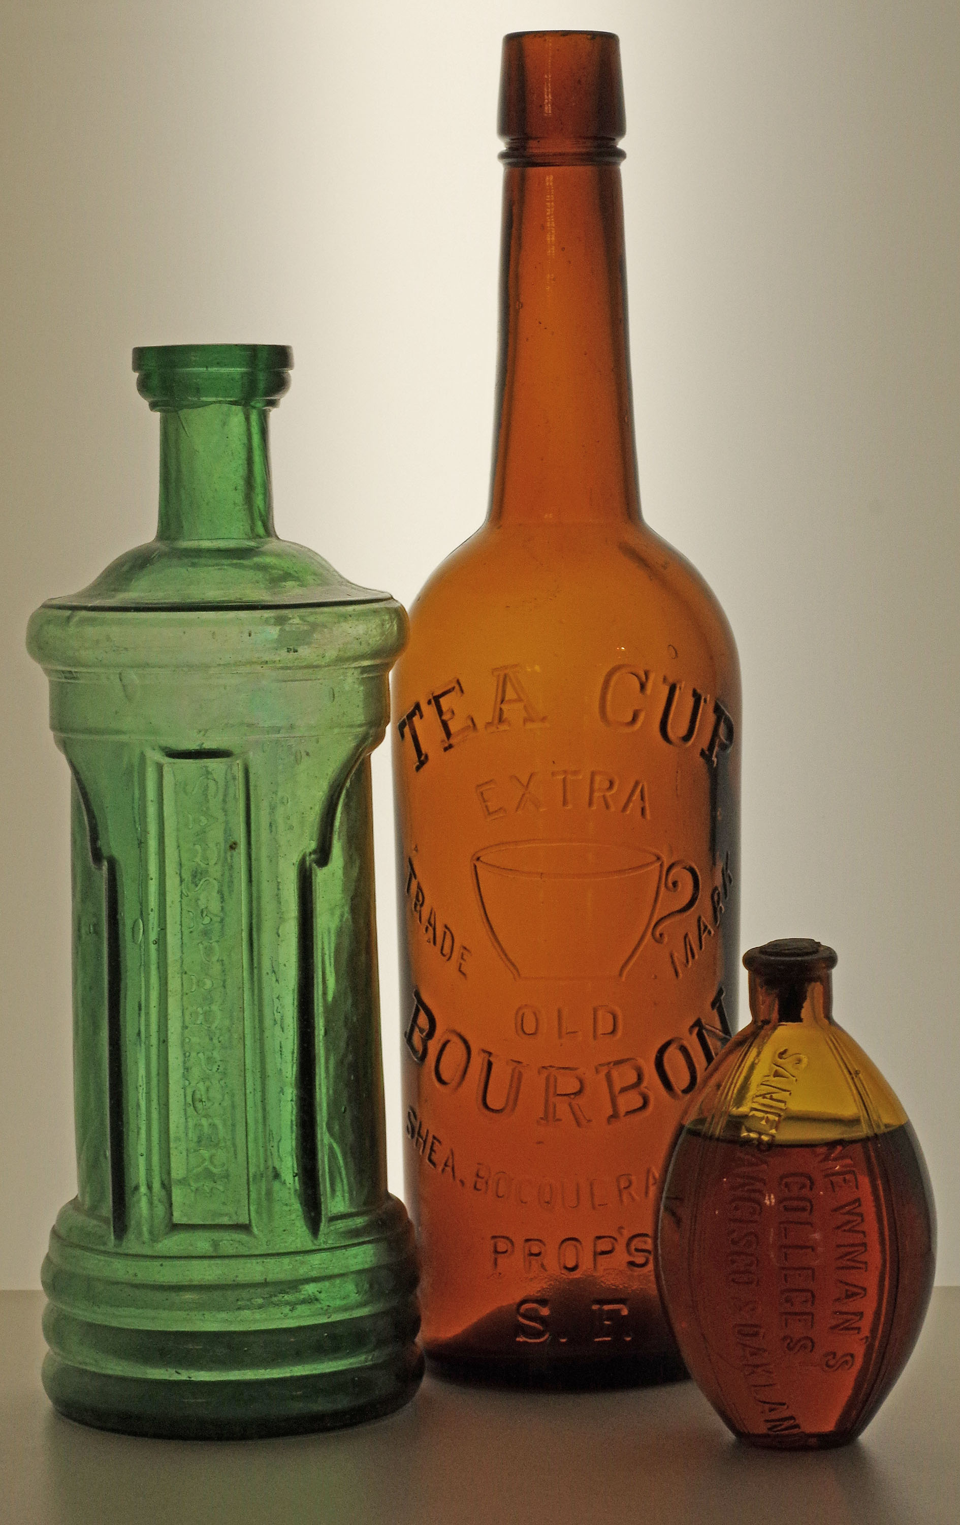 |  | 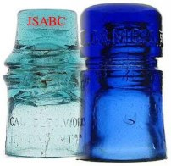
  TABLE RESERVATION FORM
  2018
  Jefferson State Antique Bottle & Insulator Expo
  May 5 & 6 2018
  Olsrud Pavilion - Jackson County Expo
  1 Peninger Road
  Central Point, Oregon 97502
  Dealer setup: Saturday May 5 ~ 8:30 to 10am.
  Early Admission: Saturday May 5 ~ 9 - 10am
  General Admission
  Saturday May 5 - 10am - 4pm
  Sunday May 6 - 10am - 3pm

Dealer's name:_______________________________________________
Address:______________________City:__________State:_______Zip:______
Phone:____________________ FAX:_____________________ EMAIL:____________________
Dealer table prices: $50.00 per table. (8' x 30")
I wish to reserve, and have included payment for ______ table(s) for a total of $________
Total number of helpers:________
Helper/Family member name(s). Name badges will be provided.
_____________________________________________________
_____________________________________________________
I understand that Show Hosts cannot guarantee a specific location. Tables will be 8'x30". Each table will have two chairs. Please provide your own table covering. At this time, there are no provisions for electrical or auxiliary lighting.
Items for sale:
Insulators, Lightning rod equipment & "Go-withs" | Approximate %________
Bottles, Jars, Stoneware, etc. | Approximate %________
Telephone and Telegraph | Approximate %________
Railroadania | Approximate%________
Other:___________________________________________
NOTE: WE ASK THAT ALL DEALERS STAY UNTIL THE SHOW CLOSES AT 3:00 P.M. ON SUNDAY. PLEASE DO NOT DISAPPOINT OUR WALK-INS. IF YOU MUST LEAVE EARLY, PLEASE MAKE PRIOR ARRANGEMENTS WITH SHOW HOSTS.
Policy regarding dealer HELPERS & FAMILY MEMBERS:
Each dealer may have an additional helper or family member. Please make arrangements with show hosts if you expect more than one helper per table. Dealers are asked to supervise their young children at all times. Those who accompany dealers must do so for the legitimate purpose of assisting the dealers.
The show hosts reserve the right to limit the number of persons per table. All approved helpers & family members are permitted inside the facility for the entire duration of show, including setup and takedown. You are asked to wear your name badges at all times.
Policy regarding EARLY BUYERS:
Early buyers are permitted NO EARLIER THAN 9AM ON Saturday, May 5, AT A COST OF TEN DOLLARS ($10) PER PERSON. Early buyers shall be provided a special badge. Dealers are not required to deal with Early Buyers until they are ready.
***********************************
No card tables or additional sales fixtures are allowed in back of any table due to fire egress requirements.
I, and my representatives (i.e. participating family members, helpers, other dealers, etc.), agree to abide by any special rules as specified in the information included in this show packet, and or any additional amendments as may be required. Any repaired, altered or irradiated sales stock must be clearly marked as such. I understand that neither the Jefferson State Antique Bottle Collectors, Show Hosts or the Jackson County Expo shall be responsible for theft, loss, or damage to person or property, from any cause whatsoever during my participation in this event.
I hereby agree to indemnify and hold harmless Glory Days Antiques, the Jefferson State Antique Bottle Collectors, Chairpersons, agents and members, and the Show Hosts, from any liability resulting from my activities at the Jefferson State Antique Bottle & Collectible Show, including, but not limited to, liability resulting from the display, offer for sale, or the actual sale of any item(s) by myself or by any of my representatives (i.e. participating family members, helpers, other dealers, etc.).
I also understand that failure to comply with the terms of this Agreement may result in my expulsion from the show premises, and/or limitations placed on my future participation in shows and activities hosted by the Jefferson State Antique Bottle Collectors.
Signature: ______________________________________________ Date: __________
Please return this completed form with check or money order made out and mailed to:
Bruce Silva
PO Box 1565
Jacksonville OR 97530
Payments made out any other way will be returned.

